**Day 38**

**What to do?**

Project #5 – Predict Stock prices using NN.

**Dataset:**

Apple Stock prices from September 15, 2015 to September 15, 2020.

**Process:**

Since the data is about stock prices, the data has been initially split in such a way that test set contains last 200 rows. Then the data was normalized, and target variables were created based on different lag values. (hence two different models).

* 1st model has lag of 10 days, i.e. predict the next day stock’s price based on previous 10 days’ price
* 2nd model has lag of 1 day (stock prices go up and down within hours, so lag of 1 day is acceptable)

Both the models went through the same NN architecture: two layers with 64 neurons in each with relu activation, and output layer with 1 neuron.

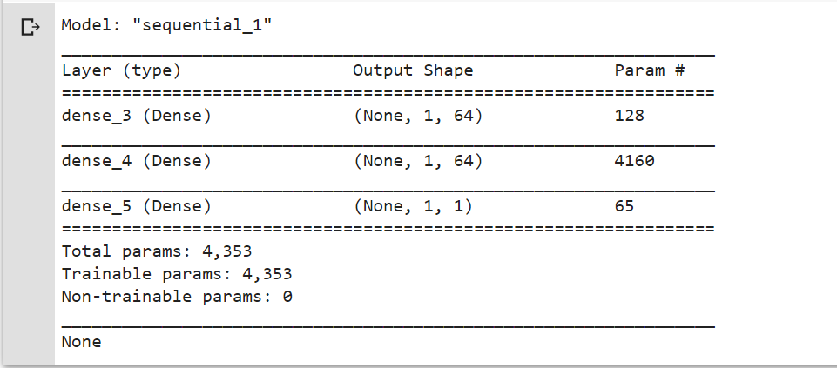

They were compiled using RMSProp optimizer with parameter value of 0.001 and loss of MSE. Finally, trained with 100 epochs and batch size of 32.

**Results:**

* Training MSE (lag = 10): 0.12%
* Training MSE (lag = 1): 0.04%

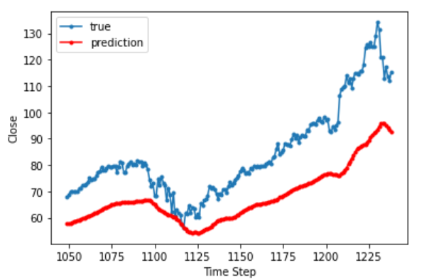

Lag = 10

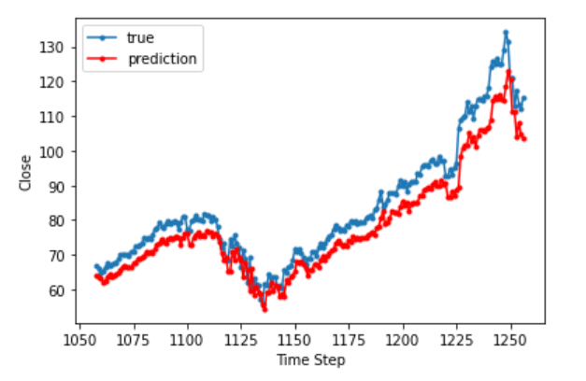

Lag = 1